INTERNETWORKING :
- Networks under same administration are generally scattered geographically. There may exist requirement of connecting two different networks of same kind as well as of different kinds. Routing between two networks is called internetworking.
- Networks can be considered different based on various parameters such as, Protocol, topology, Layer-2 network and addressing scheme.
- In internetworking, routers have knowledge of each other’s address and addresses beyond them. They can be statically configured go on different network or they can learn by using internetworking routing protocol.
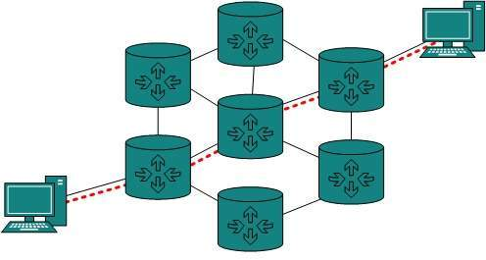
Routing protocols which are used within an organization or administration are called Interior Gateway Protocols or IGP. RIP, OSPF are examples of IGP. Routing between different organizations or administrations may have Exterior Gateway Protocol, and there is only one EGP i.e. Border Gateway Protocol.

Tunneling
If they are two geographically separate networks, which want to communicate with each other, they may deploy a dedicated line between or they have to pass their data through intermediate networks.
Tunneling is a mechanism by which two or more same networks communicate with each other, by passing intermediate networking complexities. Tunneling is configured at both ends.
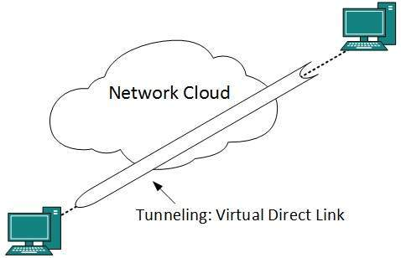
When the data enters from one end of Tunnel, it is tagged. This tagged data is then routed inside the intermediate or transit network to reach the other end of Tunnel. When data exists the Tunnel its tag is removed and delivered to the other part of the network.
Both ends seem as if they are directly connected and tagging makes data travel through transit network without any modifications.

